PHP Code for creating MySQL statements for queries of the ClassicModels database using phpMyAdmin
// Ranges: Test for a value being in a range (including the end points). This example shows only products WHERE the productScale is ‘1:12’
$sql = "SELECT * FROM `products` WHERE `productScale` = \'1:12\' LIMIT 0, 30 ";
// shows all products table information
$sql = "SELECT * FROM `products` LIMIT 0, 30 ";
// For the purpose of saving space on my post I'm going to limit the amount of results to 4, see "LIMIT 4" below and using wildcard ‘*’ to show all columns.
$sql = "SELECT * FROM products LIMIT 4";
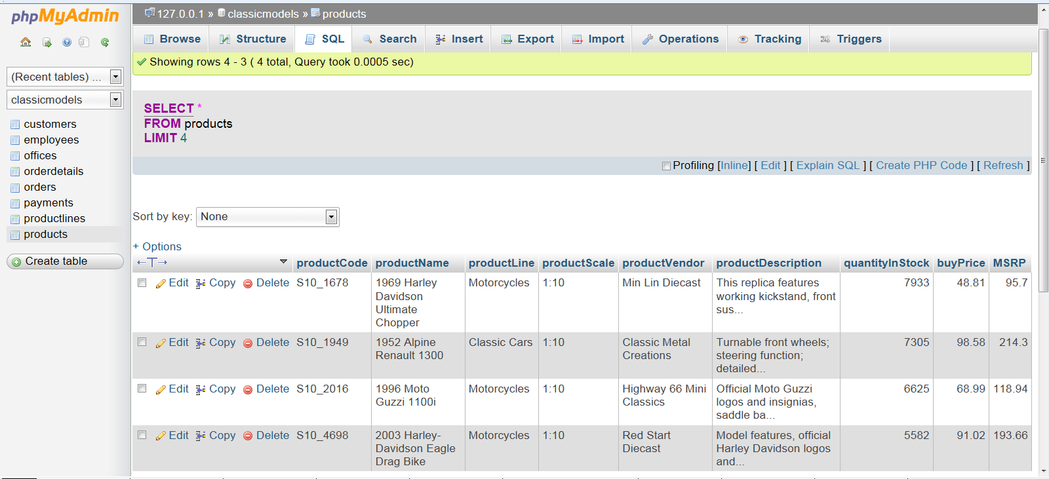
// Get rid of duplicates in the result
$sql = "SELECT distinct customerName, city FROM customers LIMIT 0, 30 ";

// Selecting Certain Rows: Comparing a column with a specific string
$sql = "SELECT * FROM products WHERE productLine = \'Motorcycles\' LIMIT 0, 30 ";

